5. Testing for Student Mark Analysis System

Aim

To develop test cases for student mark analysis System

Procedure:

**Manual Test cases for Login Form**

* Check if the User name field accepts text data only.
* Check if the Password field accepts text data only.
* Check if the Login Button display error message invalid username / password.
* Check if the Login Button display Homepage for valid username and Password.
* Check if the Cancel Button cancels the Login process.
* Check if the close window button on the program exits the program.
* Check if the minimize window button for the program minimizes the program to the taskbar.
* Check if the maximize window button for the program maximizes the program to the desktop.

**Manual Test cases for Data Entry Form**

* Check if the Register Number field is system generated or requires manual input.
* Check if the Register Number field points to the correct Register Number of the students.
* Check if the Register Number field allows alphanumeric input when under modification.
* Check if the Register Number field is editable.
* Check if the Student Name field accepts text data only.
* Check the minimum required length for the Student Name.
* Check the maximum required length for the Student Name.
* Check if the Student Name from the previous records points to the valid name for the Student.
* Check if the Student Name accepts both uppercase and lowercase input.
* Check if the Student Name does not accept any form of special character.
* Check if the Computer Networks (Marks) field accepts numeric data only.
* Check if the Computer Networks (Marks is invalid, it will display error.
* Check if the Software Engineering (Marks) field accepts numeric data only.
* Check if the Software Engineering (Marks is invalid, it will display error.
* Check if the React JS and Mongo DB(Marks) field accepts numeric data only.
* Check if the React JS and Mongo DB (Marks is invalid, it will display error.
* Check if the Software Engineering & Case Tools Lab(Marks) field accepts numeric data only.
* Check if the Software Engineering & Case Tools Lab (Marks is invalid, it will display error.
* Check the Calculate Button calculates the correct percentage and result of the student for the entered marks.
* Check if the save button saves the data.
* Verify if the save button saves the valid data.
* Check if the update button allows the modified data to be added into the database.
* Check if the update button does not retain the old information in the database.
* Check if the delete button removes the data from the database.
* Check if the deleted data using delete button does not remain in the database.
* Check if the Clear Button clears all the fields.
* Check if the report Button, Generates the Report.
* Check if the close window button on the program exits the program.
* Check if the minimize window button for the program minimizes the program to the taskbar.
* Check if the maximize window button for the program maximizes the program to the desktop.

Result : Thus the test cases for Student Mark Analysis System has been created and verified Successfully.

Program 6. Problem Analysis and Project Planning for Payroll Processing System

Aim :

To write problem Analysis and Project Planning for Payroll Processing System.

Procedure

Problem Analysis

**Introduction :**

The proposed project “Payroll processing System” has been developed to overcome the problems faced in the practicing of manual system. This software is built to eliminate and in some cases reduce the hardships faced by the existing system. Moreover this system is designed for particular need of the company to carry out its operations in a smooth and effective manner.

This web application is reduced as much as possible to avoid errors while entering data. It also provides error message while entering invalid data. It is user-friendly as no formal knowledge is required to use the system.

Human resource challenges are faced by every organization which has to be overcome by the organization. Every organization has different employee and payroll management needs. Therefore I have design exclusive Employee and payroll Management System that are adapted to the organization’s Managerial Requirements.

**Problem statement**

The admin has the full responsibility for processing the payroll system .The Admin gets logged in by valid username and password. Admin can enter Employee id, Employee name, designation, current department, basic salary. According to the basic entered the system automatically calculates House Rent Allowance (HRA), Travelling Allowance (TA), Dearness Allowance (DA), Provident fund (PF) , Gross salary and Net Salary. The admin can save above calculated pay details into the database. If there is a change particular employee’s basic pay the admin have the rights to do the change. If any employee is resigning their job the admin can delete the record from the database. Finally the Admin can generate the report to view all the past records of all recorded employees.

**Scope**

The purpose of this document is to describe the functionality and specifications of the design of a web application for Managing Employees and their payroll. The expected audiences of this document are the developers and the admin of the web application. Now with the help of this system the admin has the information on his finger tips and can easily prepare a good record based on their requirements.

Finally, we can say that this system will not only automate the process but save the valuable time of the manager or the admin, which can be well utilized buy his institute. This will be an additional advantage and management of power based on their free time from his normal duty.

Objective

“Payroll processing System” is designed to make the existing manual system automatic with the help of computerized equipment and full-edged computer software, fulfilling their requirements, so that their valuable data and information can be stored for a longer period with easy access and manipulation of the same. The required software is easily available and easy to work with. This web application can maintain and view computerized records without getting redundant entries. The project describes how to manage user data for good performance and provide better services for the client.

**Project Plan**

Gantt chart



Result : Thus the **Problem** Analysis and Project Planning for Payroll Processing System has been prepared successfully.

7. Requirement Analysis for Payroll Processing System

Aim :

To write requirement analysis for payroll processing system.

Procedure

1. SOFTWARE REQUIREMENT SPECIFICATION
   1. Non Functional Requirements:
      1. User Interface Requirements

* GUI along with meaningful Frames and Buttons
* Reports are generated as per requirements
* All details should be added in Appendices
  + 1. Hardware Requirements

|  |  |
| --- | --- |
| Hardware Environment | Intel Core i3 Processor |
| System Configuration | RAM 320 GB / HDD 2GB |
| Operating System | Windows XP |

* + 1. Software Requirements

|  |  |
| --- | --- |
| Front End | VB .NET |
| Back End | My SQL |

When invalid inputs are given to the modules then the error messages will popped up in order to inform to the user that the input provided is not taken by the database. When incomplete information is provided by the user and the user tries to submit the form in order to store the details in the database the system will pop up a message but asking the user to enter as all the details required.

* + 1. Communication Interface Requirements

The machine will have to be the part of the college Local Area Network to access the central database.

* 1. Functional Requirements

Student Mark Analysis System involves the following functions

* + 1. Login Entry Process

The valid user login name and password should be entered properly as given by the administrator.

* + 1. Payroll Data Entry Process

According to the Employee ID, Employee Name and Designation the corresponding Basic Salary should be entered in the form.

* + 1. Salary calculation Process
* As per the salary entered, the systems calculate the House Rent Allowance, Travel Allowance, Dearness Allowance and Provident Fund.
* 30% of the salary Amount will be calculated as House Rent Allowance.
* 10% of the salary will be calculated as Travel Allowance.
* 30% of the salary will be calculated as Dearness Allowance.
* 12% of the salary will be calculated as Provident Fund and it will be detected from the net Salary Amount.
  + 1. Database Access Details

To store the details entered in the GUI form, the database should be created. The following process has been used to access the database.

* Save: The Save process store all the salary details entered in the form to the database.
* Update: The Update process make changes in the database if any by entering the Employee ID.
* Delete: The delete process delete Employee details in the database by using the Employee ID of the Employee those who are going to relieve.

Result : Thus the Requirement Analysis for Payroll Processing System has been prepared successfully.

8. Design for Payroll Processing System

Aim

To design UML diagrams for Student Mark Analysis System

1. Use case diagram



2. Activity diagram



3. Class diagram



4. Sequence diagram



Data Flow Diagram (DFD)



Result : Thus the UML diagrams such as Usecase Diagram, Class Diagram, Activity Diagram, Sequence diagram and Data Flow Diagram for Payroll Processing System has been designed successfully.

9. Implementation for Payroll Processing System

Aim :

To Write a program for payroll processing system using VB.NET

Algorithm

**Coding:**

**Login form coding**

Imports System.Data.SqlClient

Public Class Form1

Private Sub Button1_Click(ByVal sender As System.Object, ByVal e As System.EventArgs) Handles Button1.Click

Try

Dim oc As New SqlConnection

Dim dr As SqlDataReader

Dim cmd As New SqlCommand

oc.ConnectionString = "Data Source=CTIT16;Initial Catalog=payroll;User ID=sa;Password=sql"

cmd.Connection = oc

oc.Open()

cmd.CommandText = "select username, password from login where username='" & TextBox1.Text & "'and password='" & TextBox2.Text & "' "

dr = cmd.ExecuteReader

If dr.HasRows Then

payroll.Show()

Else

MessageBox.Show("Invalid username or password")

End If

oc.Close()

Catch ex As Exception

MessageBox.Show(ex.Message.ToString())

End Try

End Sub

Private Sub Button2_Click(ByVal sender As System.Object, ByVal e As System.EventArgs) Handles Button2.Click

Me.Close()

End Sub

End class

**Payroll process coding**

Imports System.Data.SqlClient

Public Class payroll

Private Sub Button1_Click(ByVal sender As System.Object, ByVal e As System.EventArgs) Handles Button1.Click

Dim hra, ta, da, pf, gs As Integer

hra = Val(TextBox5.Text)

TextBox6.Text = (hra * 30) / 100

ta = Val(TextBox5.Text)

TextBox7.Text = (ta * 10) / 100

da = Val(TextBox5.Text)

TextBox8.Text = (da * 30) / 100

pf = Val(TextBox5.Text)

TextBox9.Text = (pf * 12) / 100

gs = Val(TextBox5.Text) + Val(TextBox6.Text) + Val(TextBox7.Text) + Val(TextBox8.Text) + Val(TextBox9.Text)

TextBox10.Text = gs

TextBox11.Text = gs - Val(TextBox9.Text)

End Sub

Private Sub Button2_Click(ByVal sender As System.Object, ByVal e As System.EventArgs) Handles Button2.Click

Try

Dim oc As SqlConnection

Dim da As SqlDataAdapter

Dim dt As DataTable

oc = New SqlConnection()

dt = New DataTable()

oc.ConnectionString = "Data Source=CTIT16;Initial Catalog=payroll;User ID=sa;Password=sql"

oc.Open()

Dim str As String = "insert into payprocess(empid,empname,designation,currentdepartment,basicsalary,hra,ta,da,pf,grosssalary,netsalary)values('" + TextBox1.Text + "','" + TextBox2.Text + "','" + TextBox3.Text + "','" + TextBox4.Text + "','" + TextBox5.Text + "','" + TextBox6.Text + "','" + TextBox7.Text + "','" + TextBox8.Text + "','" + TextBox9.Text + "','" + TextBox10.Text + "','" + TextBox11.Text + "')"

da = New SqlDataAdapter(str, oc)

da.Fill(dt)

MessageBox.Show("Records Inserted")

Call Button5_Click(sender, e)

oc.Close()

Catch ex As Exception

MessageBox.Show(ex.Message.ToString())

End Try

End Sub

Private Sub Button5_Click(ByVal sender As System.Object, ByVal e As System.EventArgs) Handles Button5.Click

TextBox1.Text = ""

TextBox2.Text = ""

TextBox3.Text = ""

TextBox4.Text = ""

TextBox5.Text = ""

TextBox6.Text = ""

TextBox7.Text = ""

TextBox8.Text = ""

TextBox9.Text = ""

TextBox10.Text = ""

TextBox11.Text = ""

End Sub

Private Sub Button3_Click(ByVal sender As System.Object, ByVal e As System.EventArgs) Handles Button3.Click

Try

Dim oc As SqlConnection

Dim da As SqlDataAdapter

Dim dt As DataTable

oc = New SqlConnection()

dt = New DataTable()

oc.ConnectionString = "Data Source=CTIT16;Initial Catalog=payroll;User ID=sa;Password=sql"

oc.Open()

'regno,name,cn,dnet,dbms,cnlab,dnetlab'

Dim str As String = "update payprocess set empname= '" + TextBox2.Text + "',designation='" + TextBox3.Text + "',currentdepartment='" + TextBox4.Text + "',basicsalary='" + TextBox5.Text + "',hra='" + TextBox6.Text + "',hra='" + TextBox7.Text + "',hra='" + TextBox8.Text + "',hra='" + TextBox9.Text + "',hra='" + TextBox10.Text + "',hra='" + TextBox11.Text + "'where empid ='" + TextBox1.Text + "'"

MessageBox.Show(str)

da = New SqlDataAdapter(str, oc)

da.Fill(dt)

MessageBox.Show("Records Updated")

Call Button5_Click(sender, e)

oc.Close()

Catch ex As Exception

MessageBox.Show(ex.Message.ToString())

End Try

End Sub

Private Sub Button4_Click(ByVal sender As System.Object, ByVal e As System.EventArgs) Handles Button4.Click

Try

Dim oc As SqlConnection

Dim da As SqlDataAdapter

Dim dt As DataTable

oc = New SqlConnection()

dt = New DataTable()

oc.ConnectionString = "Data Source=CTIT16;Initial Catalog=payroll;User ID=sa;Password=sql"

oc.Open()

Dim str As String = "delete from payprocess where empid='" + TextBox1.Text + "'"

da = New SqlDataAdapter(str, oc)

da.Fill(dt)

MessageBox.Show("Records Deleted")

Call Button5_Click(sender, e)

oc.Close()

Catch ex As Exception

MessageBox.Show(ex.Message.ToString())

End Try

End Sub

Private Sub Button6_Click(ByVal sender As System.Object, ByVal e As System.EventArgs) Handles Button6.Click

report.Show()

End Sub

Private Sub payroll_Load(ByVal sender As System.Object, ByVal e As System.EventArgs) Handles MyBase.Load

End Sub

End Class

Form Design

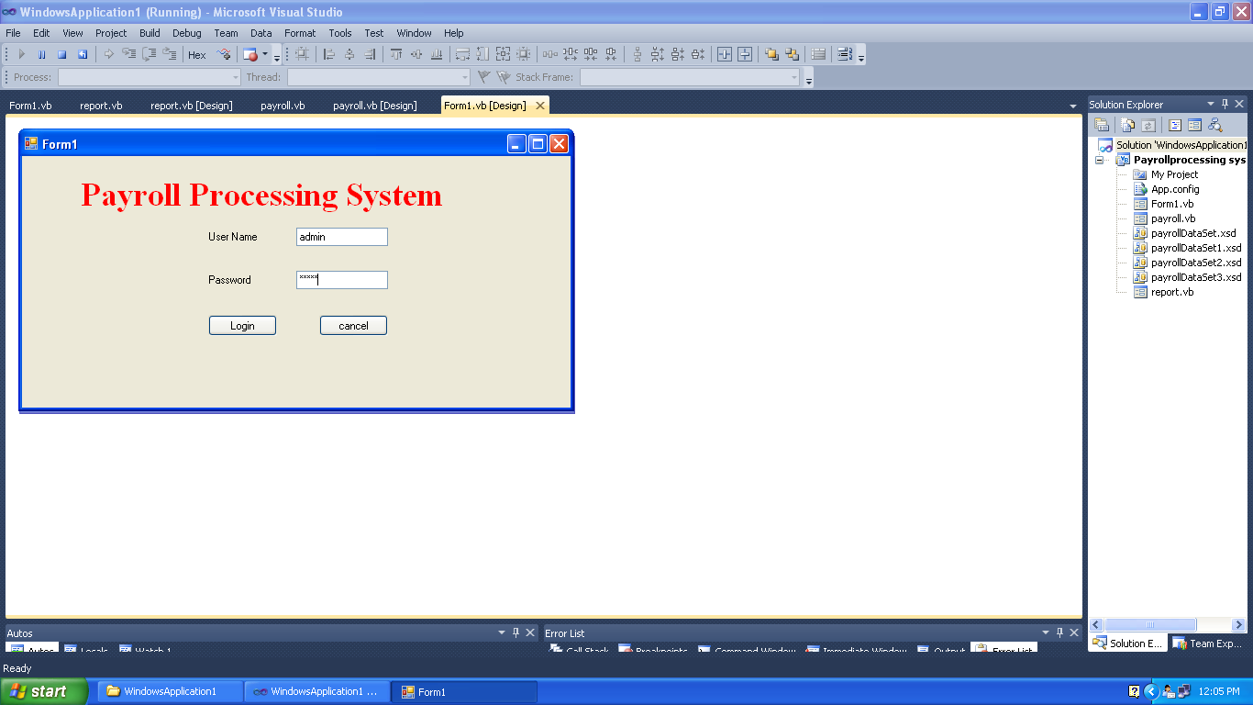

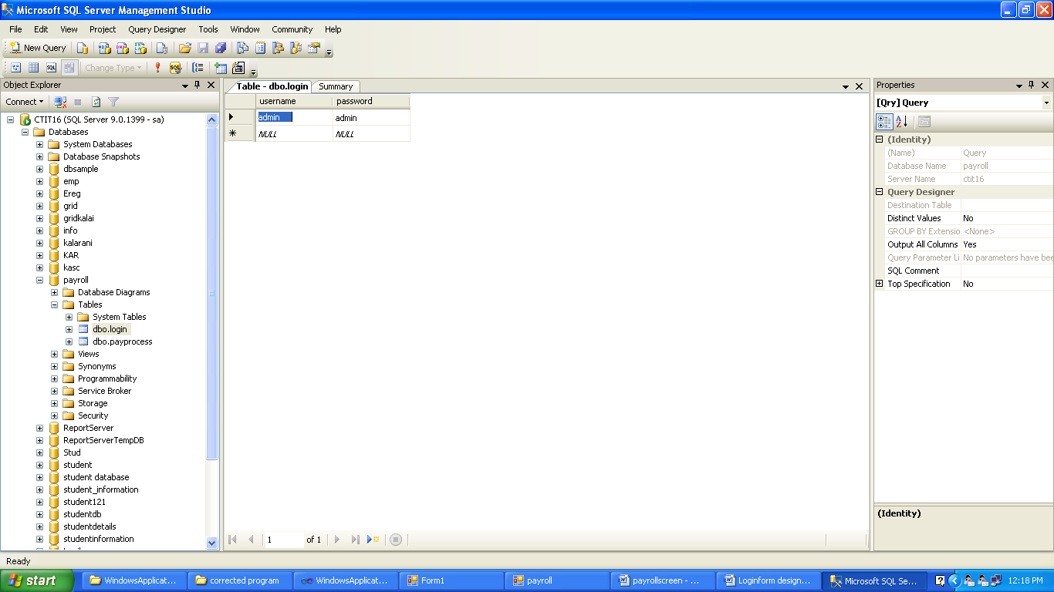

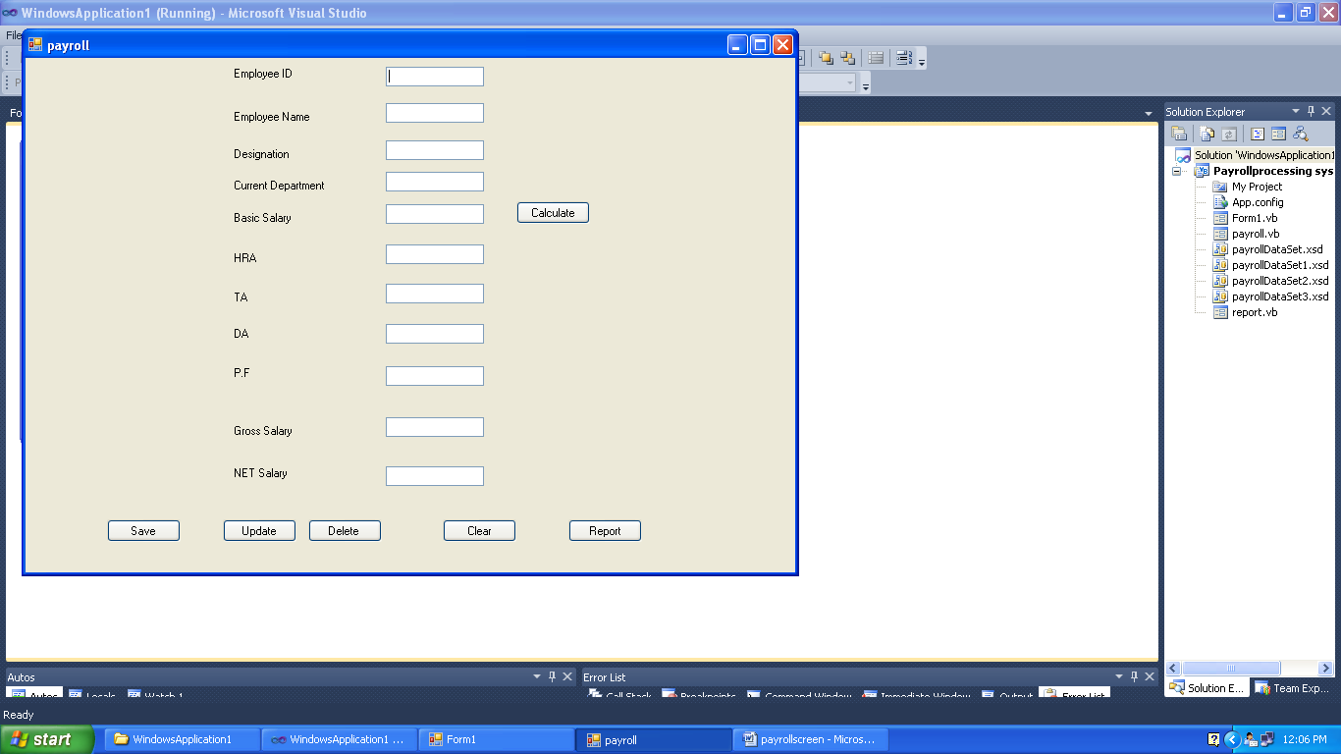

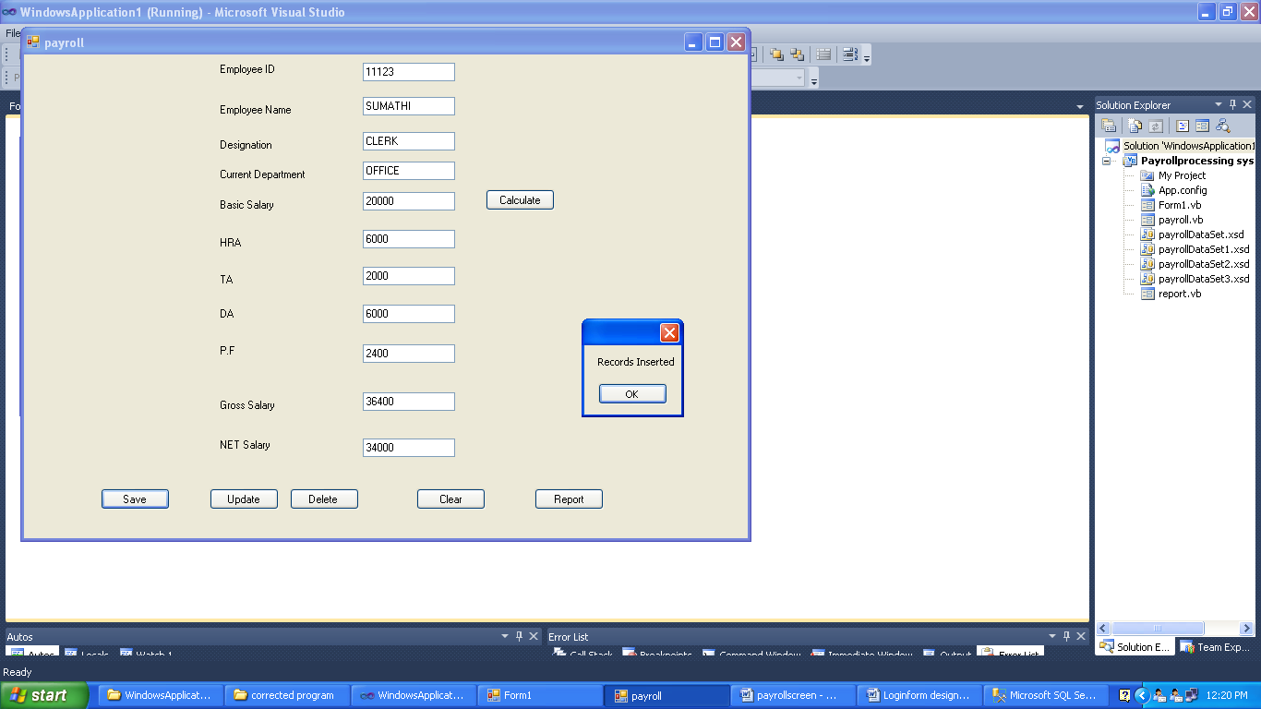

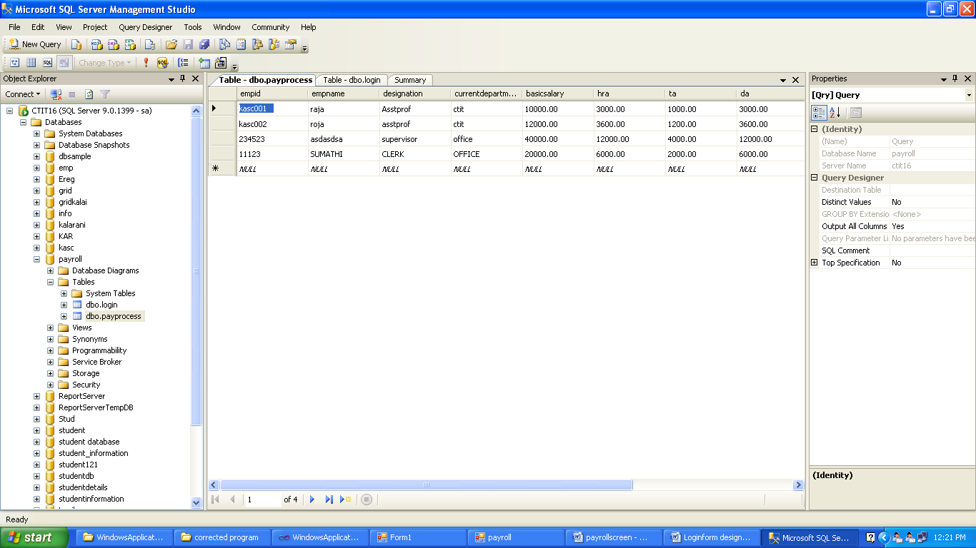

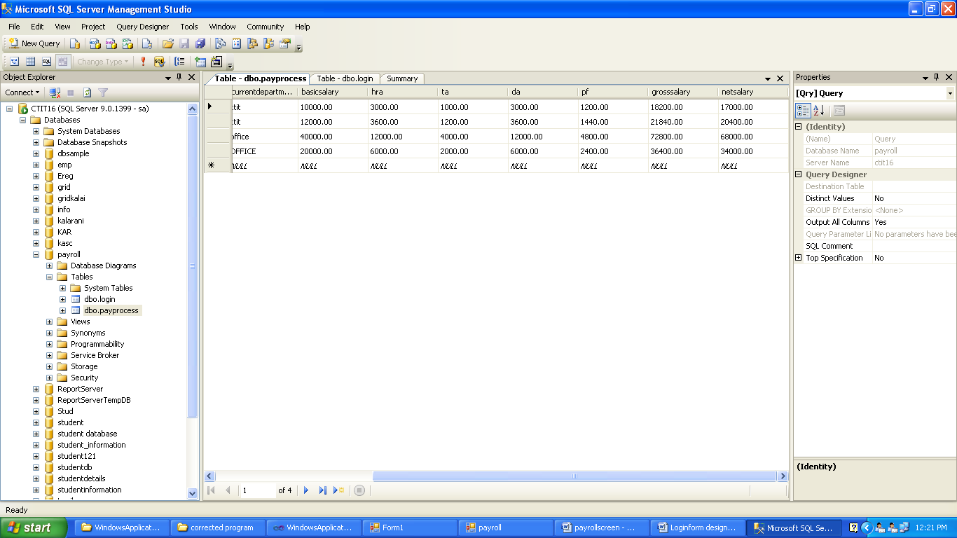

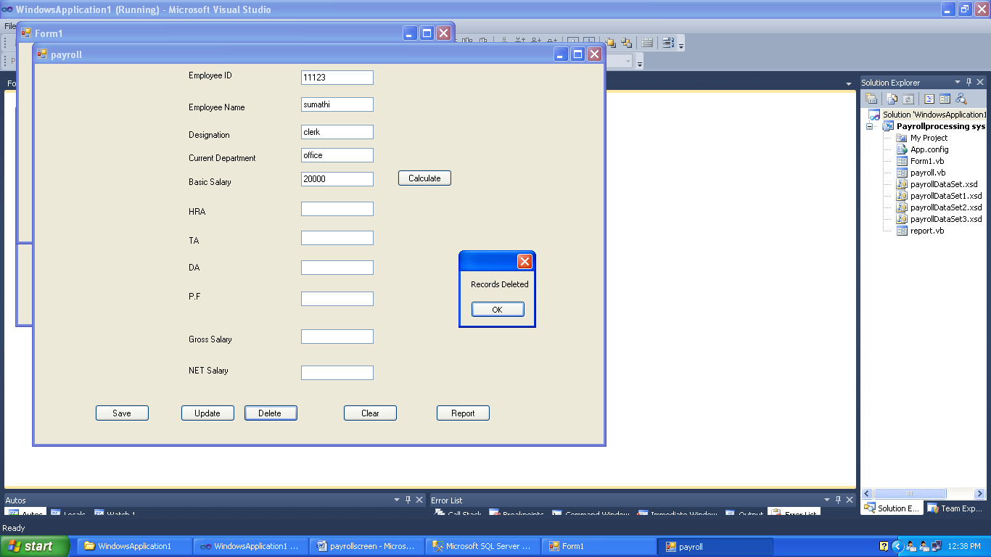

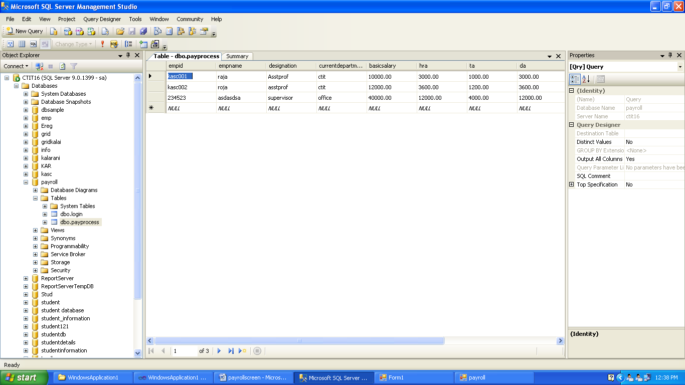

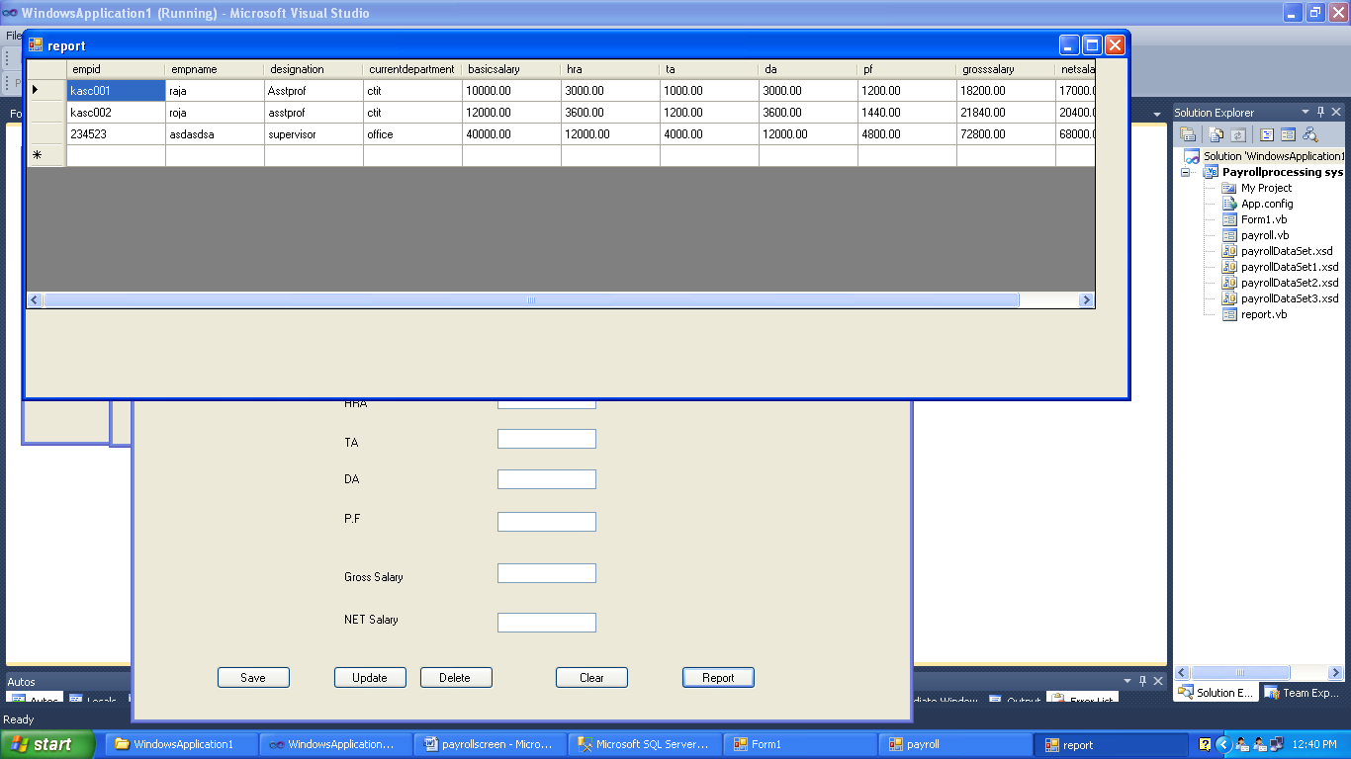

Result : Thus the payroll processing System Program has been executed and verifired successfully.

10. Testing for Student Mark Analysis System

Aim

To develop test cases for student mark analysis System

Procedure:

**Manual Test Cases for Payroll Processing System**

**Manual Test cases for Login Form**

* Check if the User name field accepts text data only.
* Check if the Password field accepts text data only.
* Check if the Login Button display error message invalid username / password.
* Check if the Login Button display Homepage for valid username and Password.
* Check if the Cancel Button cancels the Login process.
* Check if the close window button on the program exits the program.
* Check if the minimize window button for the program minimizes the program to the taskbar.
* Check if the maximize window button for the program maximizes the program to the desktop.

**Manual Test cases for Data Entry Form**

* Check if the Employee ID field is system generated or requires manual input.
* Check if the Employee ID field points to the correct employee ID.
* Check if the Employee ID field allows alphanumeric input when under modification.
* Check if the Employee ID field is editable.
* Check if the Employee Name field accepts text data only.
* Check the minimum required length for the Employee Name.
* Check the maximum required length for the Employee Name.
* Check if the Employee Name from the previous records points to the valid name for the employee.
* Check if the Employee Name accepts both uppercase and lowercase input.
* Check if the Employee Name does not accept any form of special character.
* Check if the Designation field accepts valid designations only.
* Check if the Designation is invalid, it will display error.
* Check if the Current Department field accept the department present within the company.
* Check if the Current Department field requires manual addon or if it gets auto generated.
* Check Current Department field for the minimum length of the input.
* Check Current Department field for the maximum length of the input.
* Check the Basic Salary field to verify if it is editable or not.
* Check the Basic Salary field accepts only numeric data.
* Check the Calculate Button calculates the correct House Rent Allowance(HRA),Travelling Allowance (TA), Dearness Allowance(DA), Gross Salary and Net Salary for the corresponding employee.
* Check if the save button saves the data.
* Verify if the save button saves the valid data.
* Check if the update button allows the modified data to be added into the database.
* Check if the update button does not retain the old information in the database.
* Check if the delete button removes the data from the database.
* Check if the deleted data using delete button does not remain in the database.
* Check if the Clear Button clears all the fields.
* Check if the report Button, Generates the Report.
* Check if the close window button on the program exits the program.
* Check if the minimize window button for the program minimizes the program to the taskbar.
* Check if the maximize window button for the program maximizes the program to the desktop.

Result : Thus the test cases for Payroll Processing System has been created and verified Successfully.